**The renaissance of Eric Ravilious**

**埃里克·拉维利奥斯的文艺复兴**

（英文部分选自经济学人202200709期文化版块）

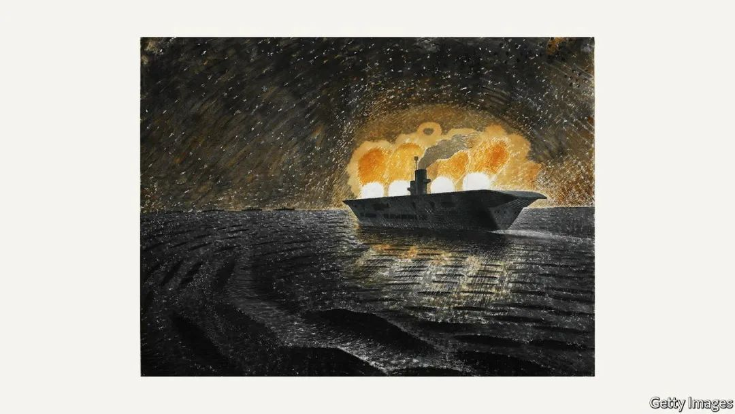

Culture | **Life in watercolour**

文化 | **水彩人生**

The renaissance of Eric Ravilious

埃里克·拉维利奥斯的文艺复兴

The English artist **languished in semi-obscurity** for many years. But his landscapes, woodcuts and war art are being **rediscovered**

这位英国艺术家多年来一直**处于半温不火的状态**，但他的风景画、木版画和战争画的价值正被人们**重新挖掘**。

Eighty years ago Eric Ravilious disappeared while on duty as an official war artist; he was part of a crew looking for a missing Lockheed Hudson aircraft. The fearless Ravilious had already seen plenty of action before his last fatal mission. His watercolours and prints of aircraft carriers illuminated by gunfire, or of the claustrophobic world of the navy’s submariners, were familiar to many in wartime Britain. 

80年前，英国政府的战地艺术家埃里克•拉维利奥斯（Eric Ravilious）在服役期间失踪；因为在搜寻一架失踪的洛克希德哈德逊飞机行动中，他加入了搜寻机组队伍，而此行却有去无回。此前，勇敢无畏的拉维利奥斯已屡次参与任务。他那些水彩画和木版画展现了被炮火映亮的航空母舰，描绘了海军潜艇的幽闭空间，这些作品在战时英国闻名遐迩。

Ravilious was one of the first names on the list when the war artists’ scheme was conceived at the beginning of the second world war by Kenneth Clark, then the director of the National Gallery. Ravilious would be the first of only three British war artists to be killed during the conflict, at the age of just 39. At the time he was beginning to **build a reputation as a significant talent**, but in the subsequent decades he almost vanished without trace. His wife, Tirzah, was left short of money and died of cancer just nine years later, leaving their three children bereft. By contrast, friends and contemporaries—such as Henry Moore, a fellow war artist and sculptor—became household names.

二战刚打响时，拉维利奥斯的名字就出现在了由时任英国国家美术馆馆长肯尼斯•克拉克（Kenneth Clark）亲自指定的首批战地艺术家名单上。英国共有三位在战争中丧生的战地艺术家，拉维利奥斯是首位丧生的，年仅39岁。他那时在绘画上**天赋异禀，声名鹊起**。但在随后的几十年中，他的名字几乎淡出人们的视野。他的妻子蒂尔扎（Tirzah）生活拮据，在他去世9年后死于癌症，他们的三个孩子成了遗孤。相比之下，他的朋友和同代人都成为了家喻户晓的人物，比如战地艺术家、雕塑家亨利•摩尔（Henry Moore）。

But the anniversary of his death in September also draws attention to a remarkable revival, mostly since the beginning of the 21st century. Earlier in the year there was **a major show of his work** at the Arc Gallery in Winchester, and on July 1st the first documentary about his life and work was released, “Eric Ravilious - Drawn to War”. In the film Ai Weiwei, a Chinese dissident artist, and Grayson Perry, a British ceramicist, among others, discuss his appeal.

今年9月的拉维利奥斯逝世周年纪念日也吸引了人们去重温卓越的艺术作品，尤其是21世纪初以来的创作。今年早些时候，英国温彻斯特（Winchester）的拱形画廊（Arc Gallery）举办了**他的大型作品展**。7月1日，首部展现拉维利奥斯生活和工作的纪录片《埃里克•拉维利奥斯：被卷入战争》上映。影片中，中国艺术家、异议人士艾未未和英国陶瓷艺术家格雷森•佩里（Grayson Perry）等人讨论了拉维利奥斯的个人魅力。

Ravilious’s images now adorn tea towels and mugs. Having died young, he did not produce a huge number of paintings and so work rarely comes up for auction. In 2014 a watercolour that had been in the same private collection since 1939 sold for £242,500 ($294,700) at Christie’s—a sum comparable to those fetched by J.M.W. Turner for similar work. More recently, a small wood engraving of a crowing rooster in a landscape, designed for a publishing house called the Golden Cockerel Press, sold for £6,400, a record for one of Ravilious’s woodcuts.

拉维利奥斯的画作如今出现在茶巾和马克杯上。由于英年早逝，他创作的画作并不多，作品也很少出现在拍卖会上。2014年，一幅自1939年以来一直收藏于上述画廊的水彩画在佳士得拍卖会上以242,500英镑（294,700美元）的价格成交，与约瑟夫·马洛德·威廉·透纳（J.M.W. Turner）的类似作品价格相当。最近，一幅为金鸡出版社（Golden Cockerel Press）设计的小型木版画以6400英镑的价格成交，该成交价创下了拉维利奥斯木版画的出售纪录，这是一幅风景画，画中有只雄鸡报晓。

With the benefit of hindsight, it is not difficult to see why Ravilious languished in semi-obscurity for so long. Born in 1903 in Acton, a dowdy suburb of west London, he remained steadfastly unfashionable for most of his life. Although he studied at the Royal College of Art—where he was taught by Paul Nash, an important influence—thereafter he rarely lived in London, let alone any other metropolis, preferring to **hole up** in the more remote parts of Essex and Sussex. This meant he was never part of any of the schools or movements that shaped his contemporaries; after his death there was no one to truly champion him.

事后看来，我们不难理解为什么拉维利奥斯几乎淡出人们视野如此之久。1903年，他出生于伦敦西部郊区落后的阿克顿，他生活的大部分时间都不合潮流。虽然他就读于皇家艺术学院，师从颇具影响力的保罗•纳什（Paul Nash），但此后他很少居住在伦敦，更不用说其他大都市了，他更喜欢在埃塞克斯和苏塞克斯更偏远的地方隐居。这意味着他并未加入过任何影响同代人的流派或运动。他去世后，没有人真正拥护他。

注释：

保罗•纳什是英国超现实主义画家和战争艺术家，同时也是摄影师、作家和应用艺术设计师。纳什是二十世纪上半叶最重要的景观艺术家之一。他在英国现代主义艺术的发展中发挥了关键作用。

His choices of medium and subject matter were equally untrendy. Ravilious was a master of wood engraving and achieved his most famous results in watercolour. Yet watercolour was widely regarded as a medium for amateurs compared with the majesty of oils and collage (despite the fact that it takes more skill to marshal the quicksilver flow of watercolour than heavier, malleable oils). He was also, primarily, a landscape painter, fascinated, most of all, by the undulating downs of his youth in east Sussex and other scenes from the countryside, at a time when most of his contemporaries **were pushing on** from Cubism towards Abstract Expressionism. He decorated ceramics for Wedgwood in the later 1930s, producing extremely popular “Alphabet” and “Garden” mugs. These were cherished by ordinary people but not by the art establishment.

他选择的创作媒介和题材也同样不合潮流。拉维利奥斯是一位木版画大师，但他的水彩画最为声名远扬。不过，与油画和拼贴画的庄严相比，人们普遍认为水彩画是业余爱好者的创作媒介（尽管与更重、可塑性强的油画相比，驾驭水彩的流动性需要更多技巧）。拉维利奥斯也主要是一位风景画家，与他而言，最具吸引力的是年轻时东苏塞克斯起伏的丘陵和其他乡间景象，而当时其大多数同时代人正由立体派转向抽象表现派。20世纪30年代后期，他为韦奇伍德（Wedgwood）公司装饰陶瓷产品，制作出的“字母表”和“花园”马克杯十分行俏。尽管这些作品广受大众欢迎，但却未被艺术界所接受。

注释：

韦奇伍德（Wedgwood），又译作维支伍德，世界上最精致的瓷器，品位的代名词。品牌创始于十八世纪，产品受到全球成功人士及社会名流的推崇，曾为俄国女沙皇叶卡特琳娜二世的专门制作餐具，著名的“罗马波特兰”花瓶现藏于大英博物馆，已经成为英国的国宝。

medium

▶the material or form used by an artist, composer, or writer.  （艺术创作）材料，素材；（艺术）表现方式

He thus had to wait until the influence of modernism had waned to be rediscovered. In this respect, argues Margy Kinmonth, the director of “Drawn to War”, Ravilious’s artistic fortunes resemble those of L.S. Lowry, another idiosyncratic artist. Ravilious was first rehabilitated through his war work, the subject of a big retrospective at the Imperial War Museum in 2003. His designs for Wedgwood have remained admired, as have many of his woodcut designs. Thousands of readers around the world will be familiar with the logo on the cover ofWisden Cricketers’ Almanack, depicting a pair of players in stovepipe hats. Few, however, will know it is by Ravilious.

因此，他不得不等待，直到日益衰落的现代主义恢复其影响力。关于这一点，《被卷入战争》的导演玛吉•金蒙（Margy Kinmonth）表示，拉维利奥斯的艺术命运与另一位特立独行的艺术家L.S.洛瑞（L.S. Lowry）类似。2003年，帝国战争博物馆（Imperial War Museum）举办了一场大型回顾展，主题是拉维利奥斯的战争画，这才使他首次恢复名誉。他为韦奇伍德设计的作品，以及众多木版画至今仍为人赏识。全世界成千上万的读者可能都熟知《威斯登板球运动员年鉴》（Wisden Cricketers’ Almanack）封面上的标志：两位戴着大礼帽的球员。然而，几乎无人知晓这出自拉维利奥斯之手。

But he is most revered by fellow artists and writers for his landscapes. Because Ravilious specialised in the quintessential English subjects of chalk and countryside, hearth and cottage, he has sometimes been romanticised as a very English, even nationalistic, painter. Yet Ravilious’s work is much more interesting than that, for there is nothing picturesque or jingoistic, let alone comforting, about any of his landscapes. As Robert Macfarlane, a writer and academic, argues, his scenes are unsettling and eerie. With very few people in his watercolours, they are “evacuated landscapes”; the eye settles instead on barbed wire, telegraph poles and waterwheels.

但是，同行艺术家和作家最敬佩的还是他的风景画。拉维利奥斯擅长描绘英国特色主题，如白垩景观、乡村、壁炉和村舍，所以有时他被称为传奇，是一位颇具英式风格、甚至带有民族主义色彩的画家。然而，拉维利奥斯作品的吸引力不绝于此。他所有的风景画既不风光旖旎，也不彰显爱国主义，给人慰藉更是无从谈起。正如作家兼学者罗伯特•麦克法兰（Robert Macfarlane）所言，他笔下的风景令人紧张不安，怪异又恐怖。在他的水彩画中，几乎看不到人物，唯有“阒无一人的风景”；看他的画，视线会落在铁丝网、电线杆和水车上。

These are exactly the elements that have drawn contemporary artists to Ravilious, including Stanley Donwood, a collaborator of the band Radiohead. “I’d like to completely absorb whatever it was that he had so that I could do it,” says Mr Donwood. The realm of Ravilious is not the England of Morris Dancers and country pubs, but of ancient hills scarred by modern life. That is why he can seem more relevant today than some of his modernist rivals.■

“Eric Ravilious - Drawn to War” is screening in British cinemas now

正是这些元素激起了当代艺术家对拉维利奥斯的兴趣，包括与电台司令乐队合作的斯坦利•唐伍德（Stanley Donwood）。唐伍德说：“我想彻底吸收他的一切，这样我也可以做到和他一样。”属于拉维利奥斯的地方不是莫里斯舞者所在的英格兰，也不是乡村酒吧，而是人们现代生活破坏过的古老山丘。这就是为什么如今的拉维利奥斯似乎比一些现代主义竞争对手更有价值。

《埃里克•拉维利奥斯：被卷入战争》目前正在英国影院上映